

**Scotch College**

**Semester One Examination, 2015**

**Question/Answer Booklet**

**MATHEMATICS METHODS (Yr 11)**

**Section One:**

**Calculator free**

**Teacher (please circle):**

**J Fletcher R Foster P Newman M Zuidersma**

**Name:**

**Time allowed for this section**

Reading time before commencing work: 5 minutes

Working time for this section: 50 minutes

**Material required/recommended for this section**

***To be provided by the supervisor***

This Question/Answer Booklet

Formula Sheet

***To be provided by the candidate***

Standard items: pens, pencils, pencil sharpener, eraser, correction fluid, ruler, highlighters

Special items: nil

**Important note to candidates**

No other items may be used in this section of the examination. It is **your** responsibility to ensure that you do not have any unauthorised notes or other items of a non-personal nature in the examination room. If you have any unauthorised material with you, hand it to the supervisor **before** reading any further.

**Structure of this paper**

|  |  |  |  |  |  |
| --- | --- | --- | --- | --- | --- |
| Section | Number of questions available | Number of questions to be answered | Working time (minutes) | Marks  available | Weighting |
| Section One:  Calculator-free | 8 | 8 | 50 | 50 | 35 |
| Section Two  Calculator-assumed | 13 | 13 | 100 | 100 | 65 |
|  |  |  |  | 150 | 100 |

**Instructions to candidates**

1. The rules for the conduct of Western Australian external examinations are detailed in the *Year 12 Information Handbook 2015*. Sitting this examination implies that you agree to abide by these rules.

2. Write your answers in the spaces provided in this Question/Answer Booklet. Spare pages are included at the end of this booklet. They can be used for planning your responses and/or as additional space if required to continue an answer.

* + Planning: If you use the spare pages for planning, indicate this clearly at the top of the page.
  + Continuing an answer: If you need to use the space to continue an answer, indicate in the original answer space where the answer is continued, i.e. give the page number. Fill in the number of the question(s) that you are continuing to answer at the top of the page.

3. **Show all your working clearly.** Your working should be in sufficient detail to allow your answers to be checked readily and for marks to be awarded for reasoning. Incorrect answers given without supporting reasoning cannot be allocated any marks. For any question or part question worth more than two marks, valid working or justification is required to receive full marks. If you repeat an answer to any question, ensure that you cancel the answer you do not wish to have marked.

4. It is recommended that you **do not use pencil** except in diagrams.

**Section One: Calculator-free (50 Marks)**

This section has **eight (8)** questions. Answer **all** questions. Write your answers in the space provided.

Spare pages are included at the end of this booklet. They can be used for planning your responses and/or as additional space if required to continue an answer.

* + Planning: If you use the spare pages for planning, indicate this clearly at the top of the page.
  + Continuing an answer: If you need to use the space to continue an answer, indicate in the original answer space where the answer is continued, i.e. give the page number. Fill in the number of the question(s) that you are continuing to answer at the top of the page.

Working time for this section is 50 minutes.

**1. [5 marks]**

Find the equation of the line passing through the point with coordinates (6, 5) and

1. parallel to the line with equation 3*x* + 2*y* = 20. **[2]**
2. perpendicular to the line with equation 2x + 4y = 10. **[3]**

**2. [5 marks]**

Find the exact values of *x* and *y* in the following triangle.

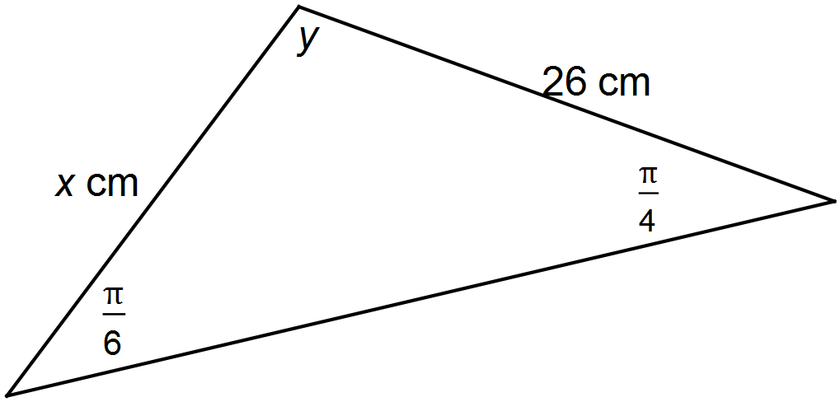

**3. [10 marks]**

Let .

For the graph of**

1. write down the coordinates and nature of the turning point **[2]**
2. write down the coordinates of the *y*-intercept **[1]**

(c) find the coordinates of both *x*-intercepts. **[3]**

A function *g* is defined as 

(d) Find the coordinates of the points where  **[4]**

**4. [7 marks]**

The graph of *y* = *f* (*x*) is shown in the diagram.

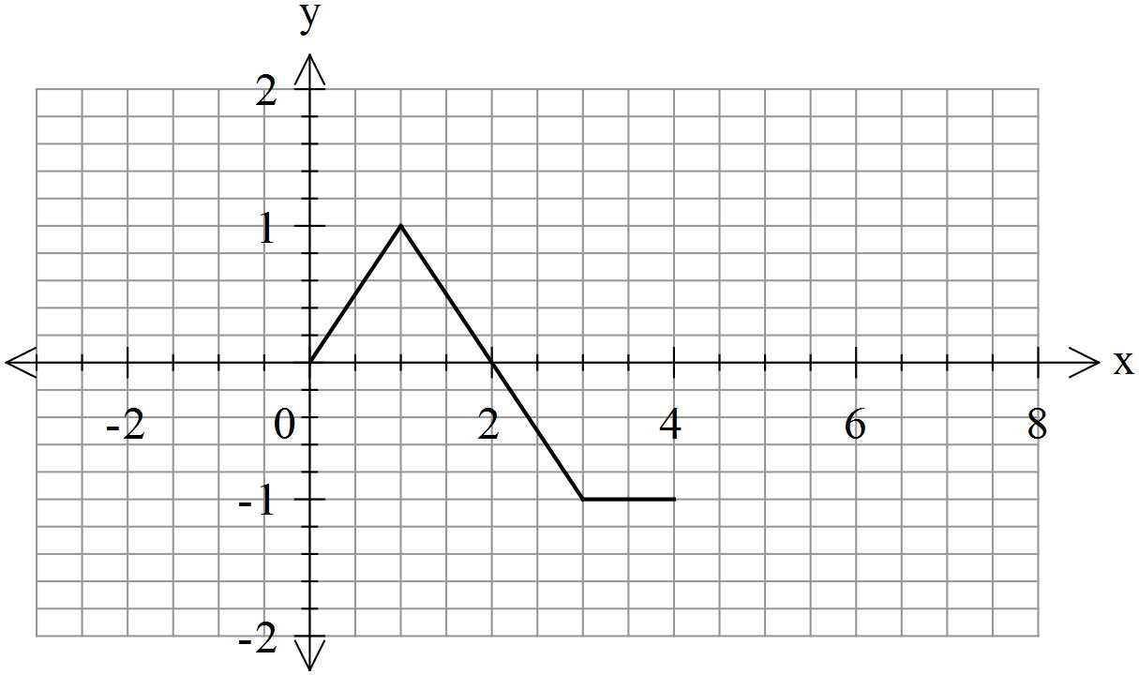

(a) On each of the following diagrams draw the required graph **[5]**

(i) *y =* 

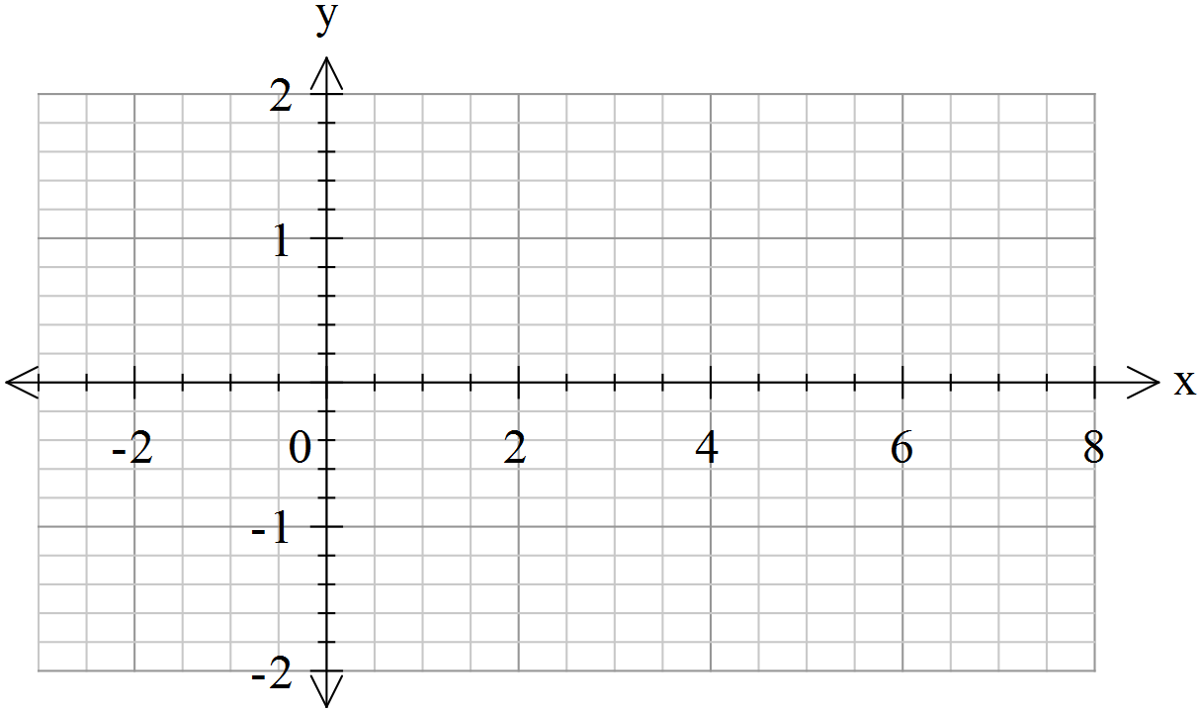

(ii) *y =*



(b) The point A (3, –1) is on the graph of *f(x)*. The point  is the corresponding point on the graph of *y* = –*f* (*x*) + 1. Find the coordinates of   **[2]**

**5. [5 marks]**

Solve 

**6. [5 marks]**

The shaded area in the diagram is a segment of a circle of radius r.

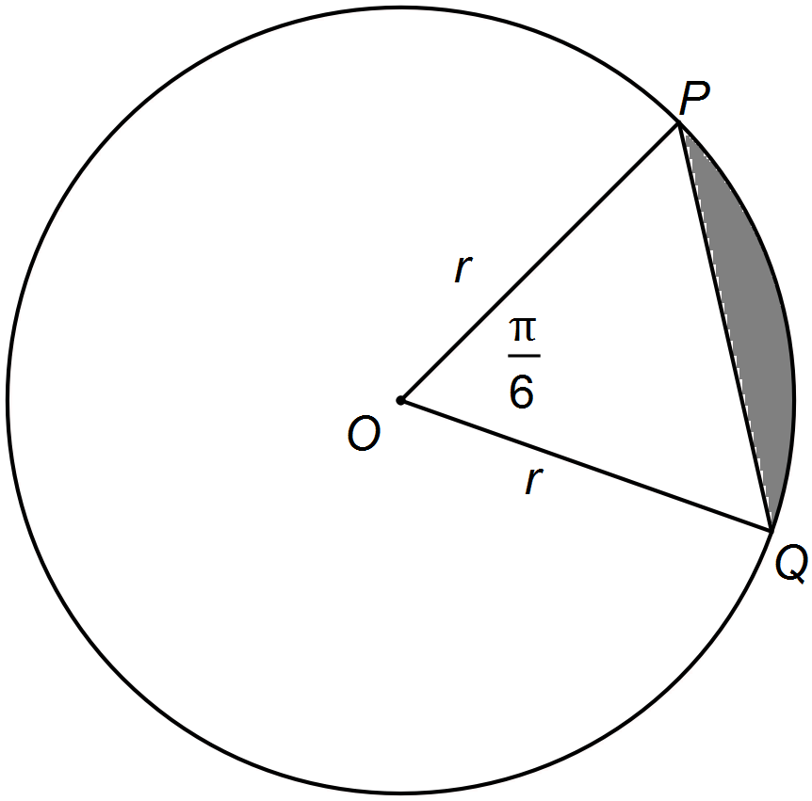

Show that the area of the segment is given by $\frac{r^{2}(π-3)}{12}$

**7. [8 marks]**

Two circles are drawn as shown.

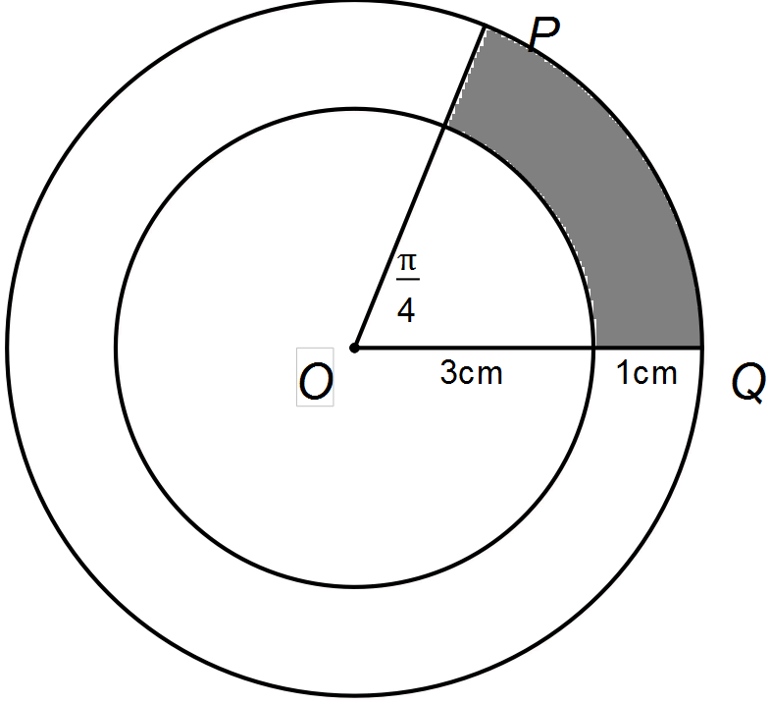

1. Find in terms of $π$
2. the length of the arc PQ **[2]**
3. the area of the shaded region **[3]**

(b) What percentage of the larger circle is sector POQ? **[3]**

**8. [5 marks]**

The diagram shows parts of the graphs of *y* = *x*2 and *y* = 5 – 3(*x* – 4)2.



The graph of *y = x*2 may be transformed into the graph of *y* = 5 – 3(*x* – 4)2 by four transformations.

Describe the transformations in the correct order.

**END OF SECTION ONE**

**EXTRA WORKING PAGES**

|  |  |  |
| --- | --- | --- |
| **Question** | **Marks** | **Result** |
| **1** | **5** |  |
| **2** | **5** |  |
| **3** | **10** |  |
| **4** | **7** |  |
| **5** | **5** |  |
| **6** | **8** |  |
| **7** | **5** |  |
| **8** | **5** |  |
| **Total** | **50 marks** |  |